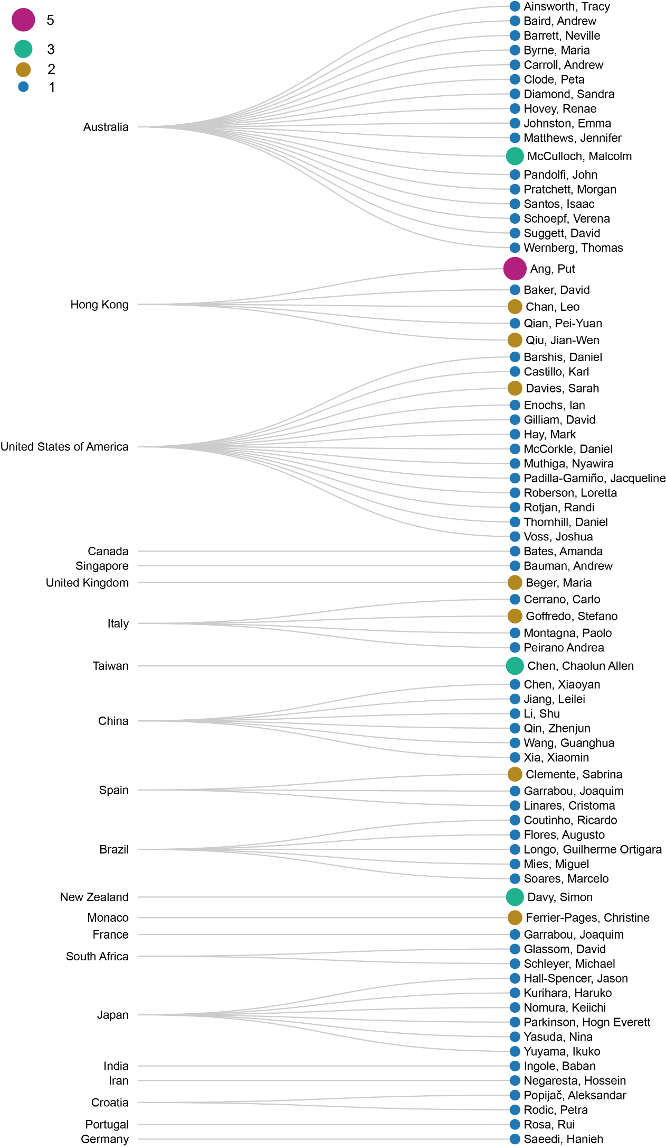

Figure 6 Linear dendrogram showing relations of last authors to countries their institutions belong to.